Testimony of
The Honorable Doctor Bill Cassidy
Member, US House of Representatives
June 17, 2010

Chairman Towns, Ranking Member Issa and other Members of the Committee of Oversight and Government Reform, thank you for calling this hearing on the national strategy to prevent and address infections with Hepatitis B (HBV) and Hepatitis C (HCV). I am a Hepatologists, which is to say a Doctor who specializes in treating liver disease. I still treat hepatitis patients as I continue to teach in a public hospital for the uninsured. I know how effective patient education, immunization and surveillance can be in preventing the spread of hepatitis and relieving the fear of those who are infected.
Among my clinical activities was founding the Greater Baton Rouge Hepatitis B Vaccination Program. In this public-private partnership, over a 6 year period, we vaccinated 36,000 public, private and parochial school children in 10 parishes. The impetus for the program was when an 18 year old girl came to the ICU with liver failure due to Hepatitis B. As she was airlifted to a liver transplant unit with an 80% chance of surviving, the thought occurred to me that we would spend $200,000 to $400,000 for her to have a liver transplant and up to $30,000 a year for the rest of her life for medications and follow-up. Yet, for $50 we could have vaccinated her against Hepatitis B and prevented the disease. In a sense, the cost of treating her because she was not vaccinated was greater than the cost of preventing the disease in her and every other young person in our metropolitan area. We were penny wise and pound foolish.

To give credit where credit is due, because President Clinton and Congress in its wisdom passed the Vaccines for Children's Program, vaccine was made available for efforts such as ours. Statistically, we know because of this program and efforts such as ours, there are those who live today and are in better health.
First, to explain hepatitis. "Hep" comes from the Greek word for liver and "itis" means inflammation. Chronic viral hepatitis is liver inflammation caused by a virus, most commonly HBV or HCV. The difference between HBV and HCV is like the difference between a dog and a cat. There are superficial similarities but they are two different species. In chronic viral hepatitis, the inflammation leads to scarring of the liver. Severe inflammation over years leads to cirrhosis. A cirrhotic liver loses function. Patients with cirrhosis are at risk for liver cancer, vomiting blood, confusion, jaundice and developing fluid overload.
HBV is primarily transmitted through exposure to blood or bodily fluids. Incidents of acute HBV infection have declined due to the advent of the Hepatitis B vaccines. However, babies born to infected mothers, spouses of those infected, recent U.S. immigrants and individuals partaking in certain unsafe activities such as IV drug use are still at a high risk of contracting HBV. HCV is spread by blood-to-blood contact.

According to the recent Institute of Medicine (IOM) Report, 3.5 to 5.3 million people are living with chronic HCV or HBV. In the next 10 years, 150,000 people in the United States will die from liver cancer and end-stage liver disease associated with HCV and HBV. Unfortunately, as many as 65%-75% of those infected are unaware that they are infected because they are asymptomatic.

While new HCV infections have declined over the past two decades, there are at least 3 million Americans with chronic HCV. According to the 2009 Milliman Report, Consequences of Hepatitis C Virus: Cost of a Baby Boomer Epidemic of Liver Disease, most of our infected population are baby boomers.

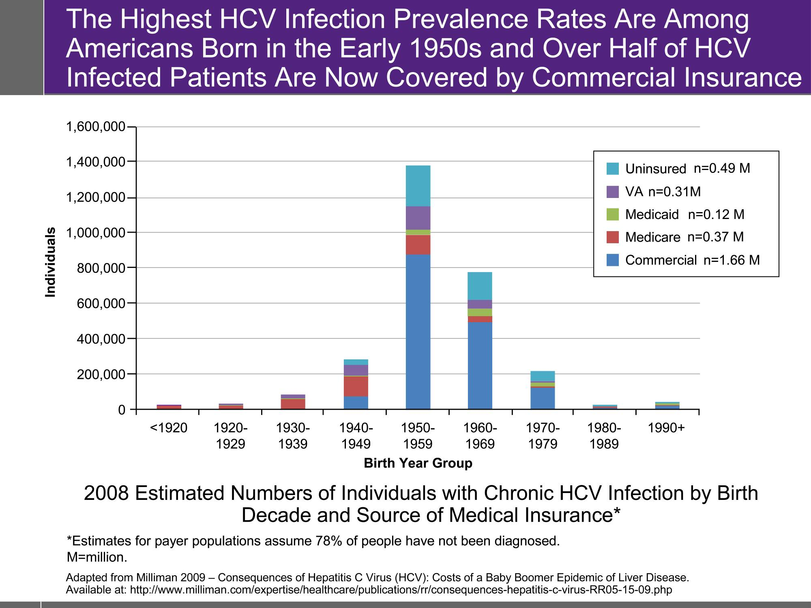

Although most individuals become infected in their twenties, HCV typically takes many years to expand to cirrhosis. Many patients do not develop cirrhosis until they reach their fifties or sixties. This report suggests a growing medical and financial burden to care for the aging HCV patient population. The February 2010 Gastroenterology Journal’s article Aging of Hepatitis C Virus Infected Persons in the United States: A Multiple Cohort Model of HCV Prevalence and Disease Progression concludes:
“Prevalence of Hepatitis C cirrhosis and its complications will continue to increase through the next decade and will mostly affect those older than 60 years of age. Current treatment patterns will have little effect on these complications, but wider application of antiviral treatment and better responses with new agents could significantly reduce the impact of this disease in coming years.”

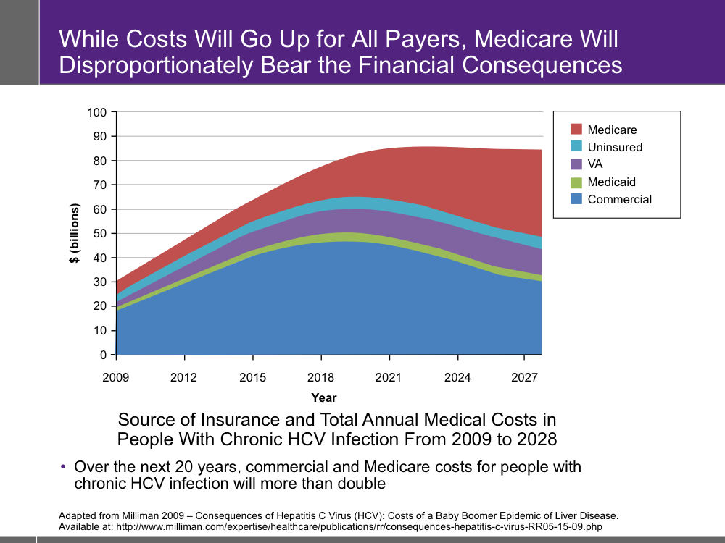

The Milliman Report indicates that without changes to the manner in which HCV is diagnosed and treated:
• Overall health care costs will more than double
• The per-patient cost of people with chronic HCV will increase 3.5 times over 20 years
• In 10 years, commercial and Medicare costs will more than double
• In 20 years, Medicare costs will increase 5-fold

The Cost of Inaction
HBV treatment costs $2,000-$16,000 per yearand HCV treatment costs $15,000-$25,000. Medical costs of HCV are predicted to increase from $30 billion to over $85 billion in 2024 primarily due to infected Americans aging into Medicare. End stage liver disease costs $30,980-$110,576 per hospital admission and an uncomplicated liver transplant cost around $314,000. The cost of inaction is too high.
What Should Be Done?
The IOM report offers some important steps we can take to further combat viral hepatitis. I agree with the report's findings that a major challenge in preventing the spread of HBV and HCV is the lack of knowledge and awareness among health care providers, the public and the at-risk population. Developing educational programs for health care providers and social service providers would help in our efforts to prevent the spread of the disease.
Surveillance, vaccination, education and screening of the diseases should be increased and integrated into clinics that serve high risk populations. The Federal Government should support current HBV vaccination programs, increase the availability of the vaccine for at-risk adults and strengthen procedures so that those who should be vaccinated are done so in a timely manner. In addition, states should be encouraged to implement programs proven to increase immunization rates. Unfortunately, there is no vaccine for HCV. Industry, academia and government can collaborate in the effort to do so.

Thank you again for inviting me to testify today. I trust that just as I testify today about a Vaccines for Children program instituted by Congress, which has saved lives and improved health, someone else in 10 or 20 years will be able to testify that she or he used a bill that we passed to diagnose, prevent and treat viral hepatitis. And this person will be able to say as I can, that because of this, there are those who are alive today and there are those who are healthier because of the wisdom of this Congress.

Soemohardjo, S., New options in the treatment of chronic hepatitis. Adv Exp Med Biol, 2003.531:p. 191-8
Fried, M.W., et al., Peginterferon alfa-2a plus ribavirin for chronic hepatitis C virus infection. N Engl J Med, 2002.347(13): p. 975-82
Pyenson, B., et al., Consequences of Hepatitis C Virus (HCV): Costs of a Baby Boomer Epidemic of Liver Disease. Milliman, Inc., 2009
Wong, L.L., P. McFall, and L.M. Wong, The cost of dying of end-stage liver disease. Arch Intern Med, 1997.157(13):p. 1429-32.
American Liver Foundation, 2002-2003. http://www.liverfoundation.org

