Subcommittee Chairman Palmer Opening Statement
"Unfunded Mandates: Examining Federally Imposed Burdens on State and Local Governments"
Subcommittee on Intergovernmental Affairs

Intergovernmental Affairs Chairman Gary Palmer (R-AL):
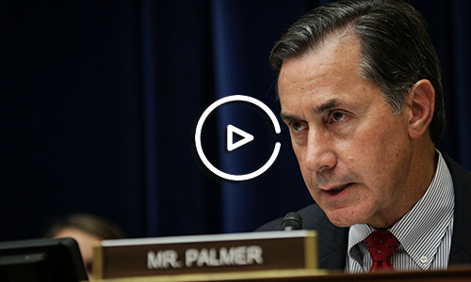

Remarks as Delivered:

Today we are examining federal unfunded mandates and their impact on state and local governments. The issue of unfunded mandates is central to this subcommittee, which is charged with oversight of the relationship between the federal government and state and local government partners.

In December the Chairman sent a letter to governors, state legislators, and county and local government officials soliciting feedback on the most burdensome or impactful federal unfunded mandates. Respondents cited over 645 individual federal laws and regulations that have taken away the ability of local governments to decide how best to serve their constituencies. Almost a quarter of those laws represented federal environmental requirements. Governor Eddie Calvo of Guam reported that compliance the costs for EPA’s enforcement of the Clean Air Act, Clean Water Act, and Safe Drinking Water Act alone equates to almost $10,000 per man, woman, and child, and makes the basic cost of utilities for the median household unsustainable.

Unfunded mandates reported to the Committee covered a variety of topics, from labor to housing to transportation to prison administration. This issue does not discriminate.

Of the most cited laws, Medicaid was routinely reported to be one of the most burdensome - imposing billions of dollars on communities annually, for care that is often not reimbursed. Higher education institutions in the State of Virginia report spending millions annually on compliance with federal educational laws. The University of Virginia, for example, spends an estimated $20 million dollars a year just to comply with unfunded mandates.

Respondents cited mandates imposing significant administrative costs with no identifiable benefits, mandates requiring standards inconsistent with the needs of the state, and mandates that are simply impossible to achieve.

In certain cases, such as implementation of new National Ambient Air Quality Standards, unfunded mandates reportedly resulted in the direct loss of jobs. The corresponding costs of these mandates are directly borne by the taxpayer. Merely looking at cost, however, is not sufficient. The time and resources that states and local governments take to comply with these mandates demonstrate that the current law does not adequately capture the extent of the burden of “unfunded mandates”.

As an example, Speaker Mac McCutcheon from my home State of Alabama shared an unworkable Department of Transportation mandate that requires the state to outline a financial plan for certain projects for up to 30 years, without knowing the source of funding that far out into the future, making this annual exercise just that. An exercise.

What we heard from nearly all of the respondents is that the attempt to provide a “one size fits all” solution effectively strips officials of the flexibility necessary to govern at the state and local level. Every dollar a state or local government uses to comply with federal law is a dollar they can’t direct to the specific needs at their own levels of government. The Committee learned that a Federal Aviation Administration policy change resulted in the use of State and local infrastructure funds to pay for flight inspections in Oklahoma. A small rural county in Nevada had to consider closing its sole library, which was residents’ key source for internet access, after the Department of Labor implemented its overtime rule.

These tradeoffs are made every day by state and local officials. I’d like to thank each of the witnesses today for taking valuable time out of their schedules to appear here today to testify. You are uniquely situated to provide insight into this issue and where we go from here. I now recognize the gentle lady from Virginia, Congresswoman Virginia Foxx, for the remainder of my time.

