Subcommittee Chairman Hurd Opening Statement
"Protecting Americans Identities: Examining Efforts to Limit the Use of Social Security Numbers"
Subcommittee on Information Technology

Chairman Will Hurd (R-TX):
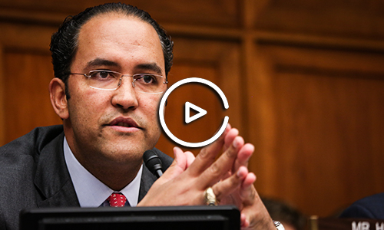

Remarks as Delivered:

In the two years plus that I've been in Congress, I've learned one thing and that is Americans expect the federal government to protect their personal information. Sadly, as evidenced by the devastating data breach at OPM, which affected more than twenty million people, this is simply not the case. The American people deserve better from their government.

If stolen, we all know that Social Security Numbers can be used to perpetrate identity theft or worse. You never know what piece of personal information the bad actors need to achieve their goals - whether they are looking to steal money or threaten the national security of our nation. The Oversight Committee recently held a hearing on the IRS data breach - where bad actors hacked into the Department of Education, stole income information from financial aid applications, and then used that information to file fraudulent tax returns with the IRS.

All of the agencies appearing before us today collect and retain a wealth of information on individual Americans, particularly Social Security Numbers. It is essential that we reduce the unnecessary use of Social Security Numbers - both on printed forms and electronically, in transition and at rest. In fact, tomorrow, the House is scheduled to consider Rep. Valadao's Social Security Number Fraud Prevention Act of 2017, which was passed out of the committee on voice vote and prohibits agencies from sending SSN's by mail unless the head of the agency deems it absolutely necessary.

The Social Security Administration has over 175 million wage earners and records on pretty much everybody, living and dead. This is a treasure trove of information that must be protected. The Veterans Administration has health records on over 8 million veterans and their families. I can imagine few other records as intimate as an individual's health record. The VA currently uses Social Security Numbers as a patient identifier. Protecting these numbers is critically important for all Americans, but given that Social Security Numbers are frequently exchanged with our most at-risk members of society, such as our seniors, disabled, and veterans, we must take utmost precaution to prevent the unnecessary risk of exposure for these populations.

One of the recommendations that came out of the Committee's investigation into the OPM breach was that agencies reduce their use of Social Security Numbers in order to mitigate the risk of identity theft. As agencies undertake this transition it is essential that they rethink how they use, collect, and store Social Security Numbers, and indeed all pieces of personal information they collect.

I'm proud to be here today with my colleagues from the Oversight Committee as well as my colleagues from the Ways and Means Committee in this important joint hearing - to examine what's working and what we can do better. Today, I hope to learn more about what efforts the federal government is taking to reduce its collection, use, and storage of Social Security Numbers.

