Subcommittee Chairmen Farenthold and Palmer Opening Statements
"Examining 'Sue and Settle' Agreements: Part I"
Subcommittee on the Interior, Energy, and Environment - Chairman Blake Farenthold (R-TX)
Subcommittee on Intergovernmental Affairs - Chairman Gary Palmer (R-AL)

Chairman Blake Farenthold (R-TX):
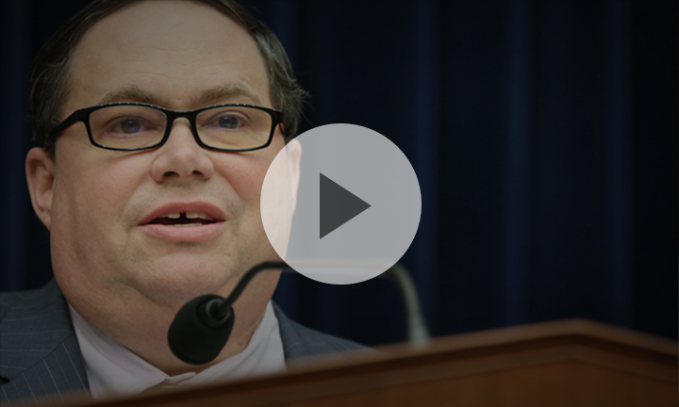

"Today, we will begin the discussion on sue and settle agreements, their impact, and potential solutions to what I consider an unacceptable and possibly unconstitutional expansion of both judicial and regulatory power. We need a solution that returns legislative authority to Congress and equally importantly, lets the American people see and have input into the process. ...

The sue and settle process creates an unfair system. The winners are the small few who manage to manipulate the federal government into doing their bidding. The losers are the taxpayers, whose hard-earned money goes to pay attorneys for both sides of the case and focuses agency resources on the plaintiff's priorities for listing and enforcements, as opposed to the other responsibilities of the agency, Congress, and the American people."

Chairman Gary Palmer (R-AL):
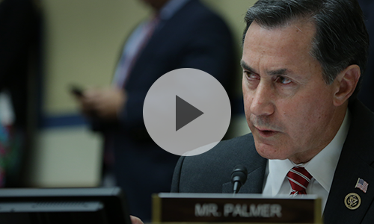

"[Sue and settle] agreements can last for decades and end up costing more than if the parties had gone to trial. Because these agreements can set provisions that extend beyond the scope of the original law violated, they are an effective tool for advocacy groups to unilaterally dictate the priorities of the agency's agenda, outside of the Administrative Procedures Act. ...

These actions place an enormous burden on states, local governments, industry stakeholders, and taxpayers, who are shut out of the negotiations but are left to foot the bill."

