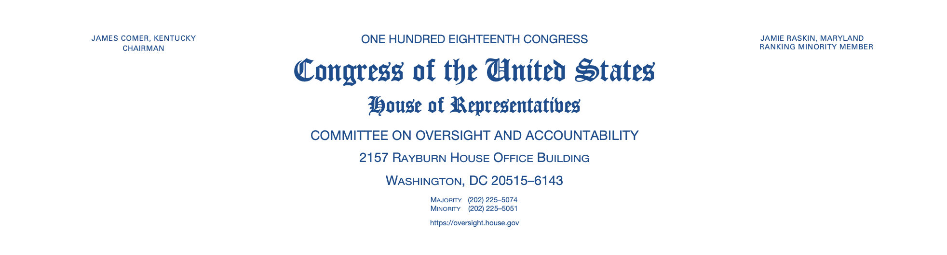

June 5, 2023

The Honorable Brian E. Frosh
Former Attorney General
State of Maryland
Transmitted Electronically
Dear Mr. Frosh:

We write to invite you to testify at a joint hearing before the Subcommittee on Economic Growth, Energy Policy, and Regulatory Affairs and the Subcommittee on Health Care and Financial Services to be held on June 6, 2023, at 2:00 p.m. ET in room 2154 of the Rayburn House Office Building. This hearing will examine how environmental, social, and governance (ESG) initiatives negatively impact businesses, consumers, and retirees.

To confirm your appearance at the hearing, please contact Committee on Oversight and Accountability staff at (202) 225-5074 by June 5, 2023. Please provide your written testimony at least two business days prior to the hearing. You will have the opportunity to provide a five-minute opening statement prior to answering questions posed by Members.

The Committee on Oversight and Accountability is the principal oversight committee of the U.S. House of Representatives and has broad authority to investigate “any matter” at “any time” under House Rule X.

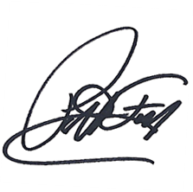
Sincerely,

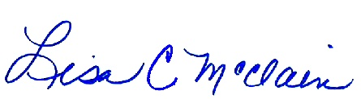

__________________________
Pat Fallon
Chairman
Subcommittee on Economic Growth, Energy Policy, and Regulatory Affairs

__________________________
Lisa McClain
Chairwoman
Subcommittee on Health Care and Financial Services

cc: The Honorable Cori Bush, Ranking Member
Subcommittee on Economic Growth, Energy Policy, and Regulatory Affairs
The Honorable Katie Porter, Ranking Member
Subcommittee on Health Care and Financial Services

